Paper C

Phase 5 of a 31-Year Managed Symbiont Progression
A Longitudinal Case Study Interpreted Through the Biochemical Computer Framework
Homo Candidus Phase 5

Jim Craddock
Redacted Science Research Initiative
Chemical Engineering, MBA, Medical Informatics Faculty
University of Oklahoma School of Medicine

Redacted Science | redactedscience.org | #TheArchitect
April 2026

1. Abstract
This paper documents Phase 5 (January 2022 to April 2026) of a progressive systemic condition spanning 31 years in a single subject. The condition is interpreted through the Biochemical Computer framework (Craddock, 2026a) and the Saline Oscillation Hypothesis (Craddock, 2026b), which propose that Candida albicans functions as a coevolved symbiont with deep signaling integration into mammalian host physiology.
Phase 5 was documented in real-time with contemporaneous lab work, medical imaging, daily journaling, self-directed urinalysis, privately ordered blood panels, and dietary intake/output records. Over 80 diagnostic tests across 12+ providers returned normal or near-normal results while the subject experienced documented organ-by-organ vascular disconnection, volume depletion, metabolic pathway substitution, and structural tissue consumption. A venous blood gas obtained in July 2025 revealed oxygen saturation of 66% on room air while simultaneous pulse oximetry read 100%, confirming a dual-circulation oxygen paradox predicted by the framework.
The subject and author are the same individual. The condition is not missed by oversight. It is invisible to standard diagnostics by design. Ten falsifiable predictions are enumerated. The record demonstrates that the condition can be managed, and that a full life can be lived within its constraints, but cannot currently be managed well because the diagnostic framework does not know it exists. [It should. It will. It is called Homo Candidus (Craddock, 2026b), and you are about to learn about stage 5 in detail. Personally, it is not my favorite stage]

2. Introduction: Why This Paper Exists
A condition that produces progressive systemic failure while generating normal laboratory results at every checkpoint does not exist within the current diagnostic framework. That is not an argument against the condition. It is an indictment of the framework. [That means the framework misses it on purpose, that is by design - THAT is some insidious level manipulation which requires every participant to be ignorant of it. Think about who could do that over the decades it would take]
The Biochemical Computer framework (Craddock, 2026a) proposes that Candida albicans, rather than functioning as an opportunistic pathogen, operates as a coevolved biochemical computer with signaling integration into mammalian host physiology through the endocannabinoid system, prostaglandin pathways, electrolyte management, and pituitary governance. The Saline Oscillation Hypothesis (Craddock, 2026b) extends this framework to population-level implications.
This paper provides the physical evidence. Not theory. Not hypothesis. Thirty-one years of one body, documented during the final four years with the precision that only a data architect with a chemical engineering degree and a faculty appointment in medical informatics would bring to documenting his own progressive organ failure, because no one else was going to do it.
The paper covers Phase 5 exclusively. Phases 1 through 4 are summarized in a staging table (3). Phase 5 is presented in exhaustive detail because every required piece of evidence exists: every lab, every imaging study, every symptom, every countermeasure attempted, every prediction made, and every "normal" result that should have triggered investigation but did not.
The subject and the author are the same person. In conventional clinical research, this would be considered a limitation. In this case, it is the only reason the record exists.
The providers who examined this subject are not named in this paper. They ran every test their training told them to run. Every test came back the way their training told them to read it. They are not guilty. They are the product of a framework that cannot detect what is happening. The framework is the problem. The providers, their training, and the tests themselves are its instruments. [All original pdf’s of lab work and conversations available online at jimcraddock.com]

3. Staging Framework
The condition progresses through five phases, each defined by an irreversible physiological transition. The transitions are not gradual. Each is anchored to a specific event, a tipping point, after which the body operates under fundamentally different hemodynamic, endocrine, and metabolic rules.

Phase 1: 1995
First documented SIADH with electrolyte crisis. Pituitary distortion begins. One adrenal gland enters slow failure. Polyuria onset. The IVC constriction is established, causing a back pressure through the circulatory system and temporarily rectifying SIADH until Central Diabetes Insipidus set in due to improper pressure differential at kidneys and increasing osmolality caused by sodium wasting and potassium retention. Retrospective interpretation: posterior pituitary exhaustion. DDAVP would have been the appropriate intervention. It was not administered because the diagnosis was not made. So, the subject [waves] had to save his own life using Redacted Science he found in a mental institution where he self-admitted due to lack of ability to sleep after 14 days by using diet caffeinated soda. (Craddock, 2025) [If that isn’t the strangest set of circumstances possible, I do not know what is. It really seems meant to be. I’m not arguing, it gave me 30 more years]

Phase 2: 2008
Salt and potassium imbalance produces cardiac shock and possible ureter collapse. Only one adrenal remains functional. The ureters are functionally lost. The bladder becomes a pressure-based filtration node. The abdomen shifts from positive to negative pressure, creating the vacuum axis that will govern perfusion for the remainder of the progression. [This is really cool, and at the same time, a remarkable feat of engineering/evolution. Almost 20 years operating in that state shows that it is not an accident. No filter lasts 20 years without being designed for it]

Phase 3: 2012–2013
The second adrenal collapses. The pituitary assumes sole governance of the endocrine system. The large intestine loses its vascular supply as former arteries pinch off one by one over approximately two weeks. First major downshift to survival physiology. [This hurts a bit as it happens]

Phase 4: 2018
A blood donation as provocation test (Craddock, 2026) on February 1, 2018, exceeded the system’s compensatory reserve. Room-spinning vertigo onset 72 hours later. Privately ordered labs on February 27, 2018, revealed urine sodium of 203 mmol/L (massive sodium wasting), urine pH of 7.5 (at range ceiling), and urine specific gravity of 1.021 (below baseline). The internal governor was disabled. This culminated with pseudo-Addisonian crisis at blood pressures that were not supported by two units of saline, with consciousness continuing through states it should not. Over the next four years, the subject gained 30 pounds, all salt and fluid loaded into interstitial spaces.

Phase 5: 2022 to Present
The IVC constriction releases on January 16, 2022. The interstitial fluid loaded over Phase 4 evacuates. Everything built over the preceding decades begins unwinding. This phase is the subject of the remainder of this paper.

4. Methods and Documentation
Documentation during Phase 5 employed the following: daily journaling (continuous from January 2022, published at jimcraddock.com); self-directed urinalysis (14-panel dipstick); privately ordered laboratory panels (Quest Diagnostics / UltaLab Tests); EPIC medical records across Saint Francis Health System, Cleveland Clinic, and multiple specialists; daily intake/output tracking in spreadsheet form (CSV, linked); antifungal cream bottle counts; Imodium dosing records; weight tracking (daily, scale verified); and blood pressure logging.
The first formal write-up of the condition was completed January 29, 2022, thirteen days after Phase 5 onset, titled "Why I KNOW I Have a Terminal Medical Condition No Doctor Has Heard Of." This document predates any Phase 5 lab results or usage of AI and establishes the subject’s framework expectations before confirmation or disconfirmation by subsequent events. Additional communication/writeups from that time and a blog are linked at the bottom of www.jimcraddock.com.

Limitations
Single subject. Self-reported symptom data (corroborated by lab values and imaging where available). No controlled intervention. No tissue biopsy obtained. A muscle biopsy was requested on multiple occasions during the arm collapse event of 2023–2024 and was declined by every provider consulted. The diagnostic test that would have confirmed or excluded the hypothesis was never performed. This is not a limitation of the study. It is a documented failure of the system the study describes.

Methodological Note on Sources and Extraordinary Circumstances

The self-citations here warrant a word of explanation. The theoretical framework in this paper traces in part to a 1995 peer-reviewed article subsequently removed from institutional access and citation indices [weird, huh?] - circumstances documented in Craddock (2026c). This leaves the author's own longitudinal works as the only extant record of both the original findings and the thirty-year case study that followed. The peer-reviewed citations provide the independent evidentiary scaffolding for the reader to see that this is not all make believe; the self-citations provide the connective architecture that no other author is positioned to supply.

A Note on Voice
When the institutions that set those conventions have demonstrated, on the historical record, that they will suppress inconvenient science and destroy the careers of the people who produce it, compliance with their stylistic expectations is not a scientific obligation. It is a social one. I have declined it.

Timeline
The next seven pages contain a timeline of Phase 5, presented in landscape format across four columns: Date, Event/Symptom/Observation, Normal Diagnostics (Documented), and Abnormal Findings/Theorized Mechanism. The timeline spans January 2022 through April 2026 and includes projected terminal events not yet occurred. Every diagnostic test referenced in this paper is placed at its documented date with the ordering provider and performing laboratory on file. The Normal Diagnostics column is deliberately comprehensive: it exists to demonstrate the volume of testing that returned nothing actionable while the subject experienced progressive, documented organ failure. Abnormal findings are noted in bold where they occurred. The theorized mechanism column interprets each event through the Biochemical Computer framework established in Craddock (2026a) and (2026b). The timeline should be read vertically as a progression and horizontally as the gap between what the subject experienced, what medicine saw, and what the framework explains.

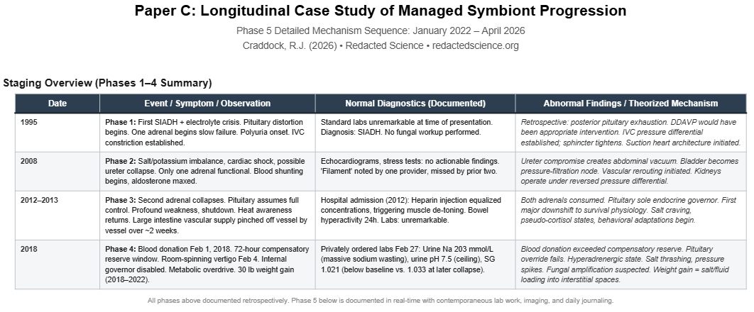

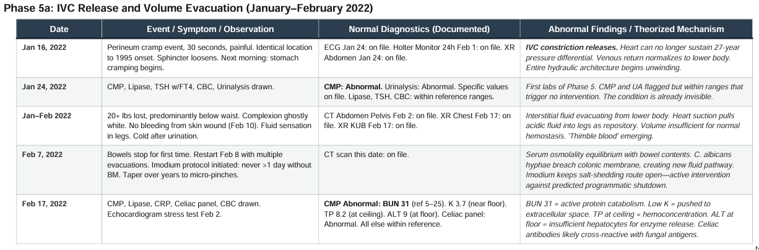

5. Phase 5a: IVC Release and Volume Evacuation
January to February 2022
On the evening of January 16, 2022, while lying in bed, the subject experienced a sudden, painful cramp at the perineum lasting approximately 30 seconds. The location was identical to the event that initiated Phase 1 in 1995. By the following morning, stomach cramping had begun. The sphincter, which had been noticeably tight for 27 years, was no longer tight.
Within the framework, this event represents the release of the IVC constriction. The heart, weakened by decades of cycling between acidic and basic states, could no longer sustain the pressure differential maintained since 1995.
Weight loss was rapid and predominantly below the waist. Per the subject’s daily CSV log: 183 lbs (pre-Phase 5) to 174.5 lbs (January 19) to 170 lbs (January 23). The subject lost over 20 pounds within weeks. The buttocks were visibly reduced. Underwear was a full size too large. Complexion became ghostly white. On February 10, the subject skinned the back of a finger. No bleeding occurred. A trace of very dark blood was visible at the wound edge.

First Documented Ketones: January 22, 2022
Per the daily CSV log, the first urinary ketones appeared January 22, 2022, at 4:40 PM, six days after the IVC release. Ketones appeared intermittently over the following weeks before the prolonged ketone periods documented in §6. On the same date, weight was 171.5 lbs despite no bowel movement, down from 173 the day prior.
Also from the CSV: on January 25 at 12:00 PM, food was noted as "feels stuck in stomach." At 7:00 PM the same day: "Ice-cream. Unable to swallow solid." This is the first documented swallowing difficulty, three weeks before the bowel stoppage on February 18.

Visit to the GI Doctor: February 17, 2022
In mid-February (2/17/2022), the subject had an appointment with a gastroenterologist. Here is a quote from Redacted Science (J. Craddock, 2025) detailing that visit:
"In 2022, I saw Dr. D. Thomas [A pseudonym]. He asked me about what was going on, my history, and he did two manual tests:
Palms pressed into my abdomen — not hard, just steady. His hands sank straight in. No pain. No tension. Nothing. He gave me a look. He’ll remember that part. He asked if it hurt — I mean, he basically turned my belly into a couple inches thick using both palms. ‘Nope.’
Then he ran his finger down my abdomen, checking nerve conduction.
“Can you feel this?” “Yes.”
Test passed. Diagnosis: ‘You’re fine.’ [I was not fine]"
In this subject’s case, the peritoneal nerve tone the doctor was testing was already compromised by a fungal peritonitis in 1995 that was never diagnosed. Candida albicans had taken out those nerves and migrated into the peritoneal lining, a third space between the layers. There it waited. Because the skin layers had also been compressed during the intervening years due to apoptosis, the nerve sensation was actually being transmitted by deeper layers of nerves than would normally be accessible to a surface exam.

Laboratory Evidence: February 17, 2022
A comprehensive metabolic panel drawn the same day at 3:20 PM:
Test | Value | Reference Range | Interpretation
Glucose | 96 mg/dL | 70–110 | Normal
BUN | 31 mg/dL | 5–25 | HIGH
Creatinine | 0.91 mg/dL | 0.72–1.25 | Normal
CO2 | 26 mmol/L | 21–32 | Normal
Na | 141 mmol/L | 135–146 | Normal
K | 3.7 mmol/L | 3.5–5.0 | Normal (near floor)
Cl | 106 mmol/L | 96–112 | Normal
Ca | 9.8 mg/dL | 8.5–10.7 | Normal
TP | 8.2 g/dL | 6.2–8.2 | Normal (at ceiling)
Alb | 4.5 g/dL | 3.4–4.7 | Normal
T.Bili | 0.6 mg/dL | 0.1–1.2 | Normal
AST | 16 U/L | 8–42 | Normal
ALT | 9 U/L | 7–40 | Normal (at floor)
eGFR | >90 | >60 | Normal

One value flagged: BUN at 31, consistent with active protein catabolism. Potassium near the floor. Total protein at the ceiling (hemoconcentration). ALT at the floor: insufficient hepatocytes for enzyme release. Celiac disease antibody panel drawn the same day returned abnormal; subsequent negative celiac HLA DQ genotyping (June 14, 2022) suggests cross-reactivity with fungal antigens rather than true celiac disease.

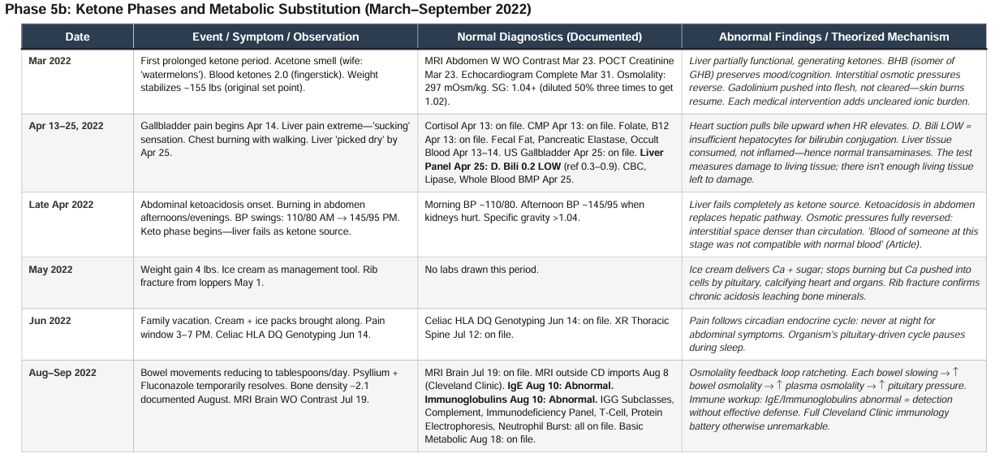

February 18, 2022: The Bowels Stop
CT abdomen performed February 2, 2022 (EPIC-confirmed, with oral contrast logged in the daily CSV at 1:00 PM), had revealed no food in the colon.
On February 18, 2022, at 10:58 AM, the subject messaged his gastroenterologist through the patient portal:
Subject, 10:58 AM: "I see my test results are all generally within normal parameters. I expected this, honestly, as it is in line with the condition I think I have. I see that it said my colon was empty, I doubt that was the case as I need to revise one answer I gave yesterday, my bowel movements are not formed. I thought they were, but this morning, when I had my very small bm (maybe 3
tablespoons) that I have been having since the diarrhea after the CT, I caught it in a tissue to see how firm it is. It is basically like thick oatmeal and only appears formed in the toilet when it drops into the water..."
"Also, I want to emphasize that the pain in my abdomen was much worse about 30 seconds after your probing, as you were leaving the room. I know that is atypical, but it is also the truth."
"I would like to discuss other options as you are the only doctor willing to look into my issues, however, I don’t have a great path forward. You are correct in that I believe I know what I have. I have written about 25 pages on it, but I don’t think a doctor would be willing to take it seriously, so I am at a loss as to how to proceed."

At 3:20 PM the same day:
Subject, 3:20 PM: "I believe my bowel has stopped. I say this because 1) they saw no food in my colon 2) my chest feels like is about to burst and 3) I cannot get any food down. I may go to the ER tomorrow if this continues."
Provider response at 5:40 PM:
Provider, 5:40 PM: "Good evening, per Dr. [Gastroenterologist] the Chest x-ray is normal. The abdominal x-ray is also normal except for what is described as calcification, which is likely the oral contrast you had for the CT scan. No bowel obstruction noted."
At 6:05 PM:
Provider, 6:05 PM: "Good evening, sounds like you may need to be seen in the ER."

The same day, February 18, the subject attended a Medical Informatics Department meeting at 1:00 PM at Perkin’s Auditorium, OUHSC. He was at work, at his faculty position, while his bowels were stopping.
That afternoon, the subject drove to his mother’s house. He told her: "I think my bowels have stopped." While visiting, he experienced a needle-sharp pain in the lower right quadrant — brief, not lasting. His bowels grumbled. They restarted the following day with fluid entering through the weakened colon membrane.
Within the framework, the delayed palpation pain (30 seconds after the physician left the room) is not peritoneal rebound. It is mechanical disturbance of organism activity in or adjacent to the peritoneal space, producing a delayed inflammatory cascade that peaks after the examination window has closed. The finding is real. The exam is not designed to capture it.
The "calcification" attributed to residual oral contrast is, within the framework, potentially actual calcification from the pituitary-driven calcium deposition mechanism the subject was actively documenting. The finding was handed to the subject and explained away in the same sentence.
The needle pain in the RLQ at his mother’s house is the moment of colonic membrane breach. Sharp, brief, localized: hyphae penetrating the wall. The grumbling represents fluid from the peritoneal space finding its new pathway into the colon.

The Imodium Intervention
At a point during early Phase 5 (exact start date not documented), the subject initiated an Imodium protocol: never allow more than one day without a bowel movement. The Imodium was tapered over years from standard doses to micro-pinches. The subject was aware that Imodium raises osmolality and feared contributing to the cascade he was trying to prevent. The titration to micro-doses reflects an attempt to balance bowel stoppage (catastrophic) against iatrogenic osmolality increase (incremental).
This intervention is not symptom management. It is active interference with a predicted programmatic sequence. The organism expects the bowels to stop. The subject would not let them.

§6. Phase 5b: Ketone Phases and Energy Pathway Substitution
March to September 2022
By March 2022, the subject’s weight had stabilized near 155 pounds, matching the original set point at Phase 1 entry. The first prolonged ketone period was underway. The subject could smell acetone. His wife described the smell as watermelons. Blood ketones measured by fingerstick reached 2.0 mmol/L. Beta-hydroxybutyrate (BHB), the most common ketone in the mammalian body, is an isomer of gamma-hydroxybutyrate (GHB) (Shima, N., et al.,2005). This biochemical relationship accounts for preserved mood, cognitive clarity, and energy during a period of systemic organ failure.

The Provocation Test
In approximately March 2022, the subject conducted a deliberate provocation test: one-third of a mile running, one-third walking, on a track. The purpose was not to demonstrate a metabolic state for documentation. The purpose was to find out whether it would kill him. The subject had performed similar exertion tests after previous transitions. It was one way of saying "I’m not dying yet."
By the end, he was drenched in sweat and barely functional. Urinalysis immediately after showed urine loaded with ketones. There had been no ketones the day before. There were none the day after. A single brief exertion event consumed the body’s emergency reserves and dumped the metabolic waste into urine. The body could produce motion. It could not fuel it. If he had not tested, he would never have known.

The Liver Panel: April 25, 2022
The subject described this date as the day the liver was "picked dry."
Test | Value | Reference Range | Interpretation
Albumin | 4.4 g/dL | 3.4–4.7 | Normal
TP | 7.9 g/dL | 6.2–8.2 | Normal
T.Bili | 0.8 mg/dL | 0.1–1.2 | Normal
D.Bili | 0.2 mg/dL | 0.3–0.9 | LOW
Alk Phos | 58 U/L | 39–139 | Normal
AST | 14 U/L | 8–42 | Normal
ALT | 8 U/L | 7–40 | Normal (at floor)

Direct bilirubin at 0.2, below the reference floor. The liver is not conjugating bilirubin because there is not enough functional liver tissue to perform the conjugation. AST and ALT confirm: the liver is not being damaged. There is not enough liver left to damage.

June 2022: The Psyllium Trigger
The subject had not been in significant pain leading up to the family vacation in June 2022. On the day of departure, he took two psyllium husk capsules (1,500 mg each, 3,000 mg total), substantially more than the micro-doses he would later learn to calibrate. This triggered the next set of abdominal pains. Within the framework, the excess psyllium created a bolus that the already-compromised bowels could not process at normal transit speed, producing mechanical distension and osmotic stress in a system operating at the margins of motility.
Pain onset occurred daily during this vacation after the initial psyllium dose. The subject did not connect the two at the time. Every afternoon brought level 4 pain, a level at which a normal person would be seeking acute care management. The subject continued normal vacation activities, including a painful jet ski ride with his son. Antifungal cream and ice packs had been brought along.

The Mechanical Walk
During the spring 2022 ketone transition period (exact date unconfirmed; the subject logged the event the following day in a document that has not been located), the subject experienced a neuroenergetic failure event.
He took a hot shower — the best shower of his life, by his own description. Everything felt right. The tension eased. Afterward, he sat in the recliner to relax. Over approximately fifteen minutes, he noticed something was off. A headache developed. Then he told his wife he needed to go to bed.
He stood up and could not walk well.
His wife came and helped him to the bedroom. As he walked with her support, he noticed something specific: he could walk normally if he literally concentrated on each individual movement instead of relying on the muscle memory of how walking worked. Automatic locomotion had failed. Conscious, deliberate, step-by-step motor commands still functioned. The hardware worked. The software was lagging.
By the next day, it had resolved. The nervous system adapted to the new fuel source. The transition cost one night of manual override, then alignment. [Let me just add this is a very important date and I apologize for losing the document somehow over the last 4 years. I’m sure science will find the precise timing and mechanism in time. But, that shower was glorious. Then, within 30 minutes or so, I began getting prickling sensations all over and a headache. This is supposedly (according to the article) a one-time occurrence on every person’s path in Homo Candidus when their primary energy supply switches to ketones. Those are my clues, I hope it helps.]

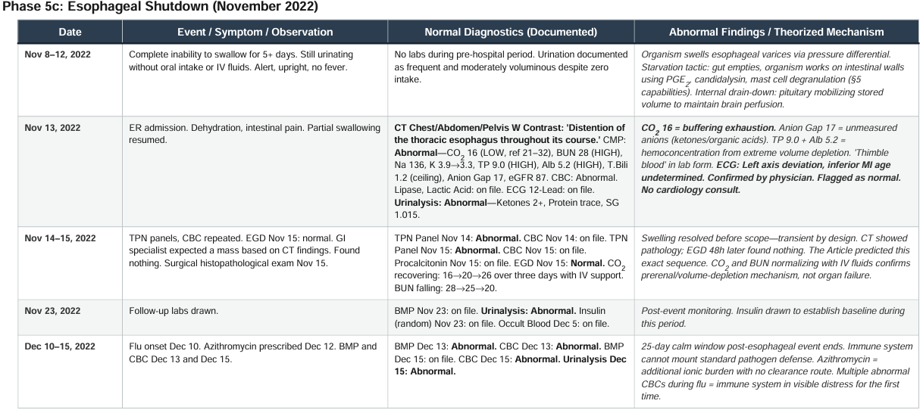

7. Phase 5c: The Esophageal Shutdown
November 2022
On or about November 8, 2022, the subject lost the ability to swallow. The onset was sudden and complete. For five days, the subject consumed nothing. He remained alert, upright, afebrile. He continued to urinate — frequently and with moderate volume — without oral intake or IV fluids. [I know five days before I went to the ER. Sometimes, you just make other people a priority in life. That was one such time.]

The Emergency Room: November 13, 2022
CMP drawn at 11:17 AM. The most abnormal labs of Phase 5:
Test | Value | Reference Range | Interpretation
Glucose | 85 mg/dL | 70–110 | Normal
BUN | 28 mg/dL | 5–25 | HIGH
Creatinine | 1.03 mg/dL | 0.72–1.25 | Normal
CO2 | 16 mmol/L | 21–32 | LOW (severe)
Na | 136 mmol/L | 135–146 | Normal (low-normal)
K | 3.9 mmol/L | 3.5–5.0 | Normal
Ca | 10.1 mg/dL | 8.5–10.7 | Normal
TP | 9.0 g/dL | 6.2–8.2 | HIGH
Alb | 5.2 g/dL | 3.4–4.7 | HIGH
T.Bili | 1.2 mg/dL | 0.1–1.2 | Normal (at ceiling)
AST | 18 U/L | 8–42 | Normal
ALT | 9 U/L | 7–40 | Normal (at floor)
Anion Gap | 17 | 5–17 | Normal (at ceiling)
eGFR | 87 | >60 | Normal

CO2 at 16: buffering exhaustion. TP 9.0 and Alb 5.2: hemoconcentration from extreme volume depletion. Anion Gap at ceiling: unmeasured organic acids. CT imaging: "Distention of the thoracic esophagus throughout its course." EGD two days later: normal. The GI specialist expected a mass. Found nothing.
ECG at 6:25 PM: left axis deviation, inferior myocardial infarct age undetermined. Confirmed by physician. Flagged as normal. No cardiology consult. The subject learned of this finding by reading his own medical record in the patient portal. [How’s that? Yes, the first time I learned I had a heart attack at some point in my life was looking up my own “Normal” EKG. Realize, I’ve have at least 3 stress echocardiograms. One even said I had a Chiari network A completely benign embryological leftover that probably gave someone a moment of pause and generated a follow-up or two for no clinical reason. “Classic incidental finding” – but no heart attack.]

Additional Insult – December 10-15, 2022 – Flu Onset
Subject came down with Flu (Positive screen).
Azithromycin prescribed even though not needed, representing additional salt burden with no clearance route. [Personally, it felt like my head was buzzing while I was on this prescription].

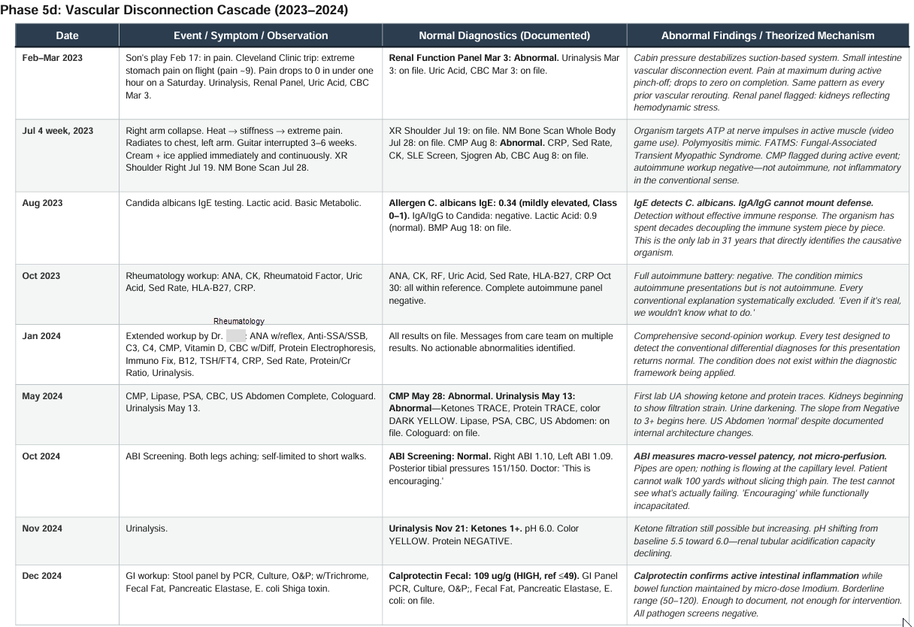

§8. Phase 5d: The Vascular Disconnection Cascade
2023 to 2024
A diagnostic signature emerges: when a vascular structure completes its disconnection from a major organ, pain goes from maximum to zero. Not gradually. Within minutes. The pain stops because the disconnection is finished. There is nothing left to hurt. [It is glorious, honestly. Just gone. The Article said that men would cheer when the kidney finally went. I assume due to the pain level]

Small Intestine Disconnection: February 2023
Cleveland Clinic trip for neurological evaluation. Extreme stomach pain on the flight (pain ~9). Pain dropped from 9 to 0 in under one hour on a Saturday morning. Renal function panel March 3: abnormal.

The Arm Collapse: July 2023
Week of July 4, 2023. Sudden onset: heat, stiffness, extreme pain in right arm. Radiates to chest, left arm within 48 hours. Minor bump from family member triggered blackout-level pain. Guitar interrupted 3–6 weeks, resumed through pain. Cream and ice applied immediately and continuously. Nine-month total duration. Pregabalin effective for nerve pain component, discovered about 5 months into the period.
Candida albicans IgE (August 11, 2023): 0.34 kU/L, mildly elevated. IgA and IgG to Candida: negative. The only lab in 31 years that directly identifies the causative organism. Detection without defense. Noted. Not acted upon. [Thanks for the test results, though. Another brick in the wall]

The Leg Decline: 2024
ABI screening October 1, 2024: Right 1.10, Left 1.09. Normal. "This is encouraging." The subject could not walk 100 yards. EMG August 18, 2025: "NO findings of primary myopathy." Motor amplitudes trending low. The legs were failing. The tests could not find them failing.
The improvement in acute leg pain while weakness persists follows the same pattern as the arm: flare → collapse → compensate → stabilize. The slicing pain was the active phase: organism harvesting substrate. Once the harvest completed, the acute pain ceased. The weakness persists because the muscle tissue has been permanently reduced. The pain was the process. The weakness is the result. The organism does not revisit completed harvests. It moves to the next target.
Fecal calprotectin (December 4, 2024): 109 ug/g (normal ≤49). Active intestinal inflammation confirmed. Borderline. Enough to document, not enough for intervention. [Yes, I refused a colonoscopy. Realize a colonoscopy changes all your fluid gradients and introduces an additional salt load. The Article made it clear this was the likely path – tests and salts were to be avoided. If he had said, “I’ll take tissue samples to culture for Candida” I might have, I honestly do not know.]

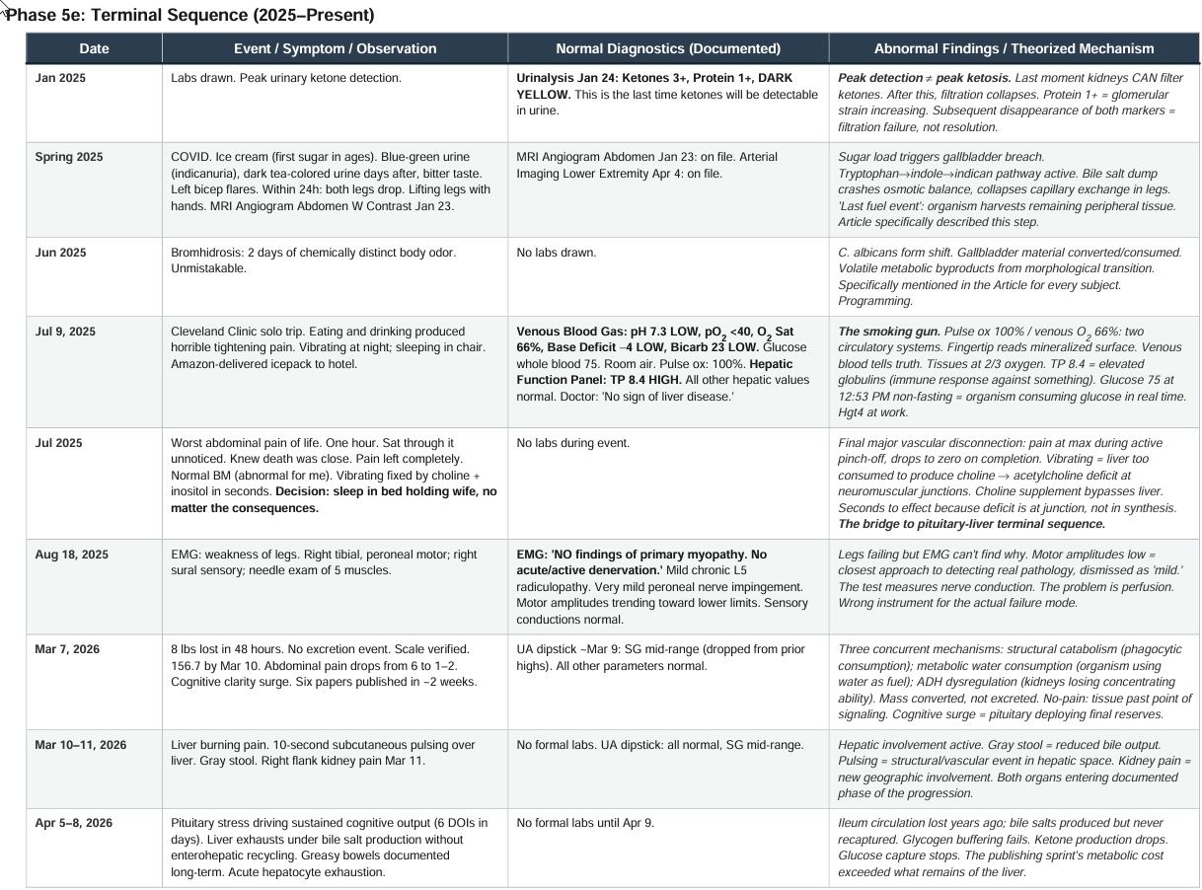

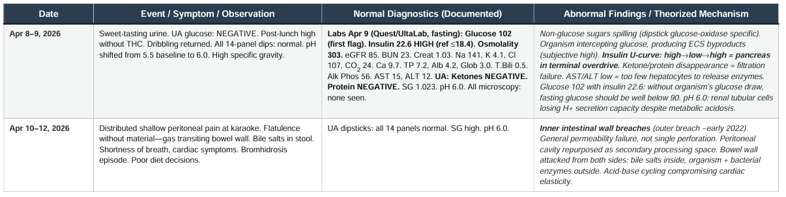

§9. Phase 5e: The Terminal Sequence
2025 to Present

The Ketone Trajectory as Filtration Failure
Test | Value | Reference Range | Interpretation
Aug 07, 2023 | NEGATIVE | — | Kidneys filtering normally
May 06, 2024 | TRACE | — | Filtration beginning to strain
Nov 21, 2024 | 1+ | — | Filtration declining
Jan 24, 2025 | 3+ | — | Peak detection; kidneys at max
Apr 09, 2026 | NEGATIVE | — | Filtration failure

The return to Negative is not improvement. It is the kidneys losing the ability to filter ketones. The subject is likely still ketotic. The kidneys can no longer show it.

The Venous Blood Gas: July 9, 2025
Test | Value | Reference Range | Interpretation
pH, Venous | 7.3 | 7.32–7.42 | LOW
pO2, Venous | <40 mmHg | 35–45 | At/below floor
O2 Saturation | 66% | 60–85% | LOW
Base Deficit | -4 | -2 to 0 | LOW
Bicarbonate | 23 mmol/L | 24–28 | LOW
Glucose, Whole Blood | 75 mg/dL | 60–105 | Normal (low)
Pulse Oximetry | 100% | — | Simultaneous

Venous O2 saturation 66%. Pulse oximetry 100%. Two numbers from the same patient that cannot both be true in a single circulatory system. They are both true because there are functionally two systems. The hepatic panel the same day: "No sign of liver disease." Total protein 8.4 HIGH.

The Terminal Pain Event
After returning from the Cleveland Clinic in July 2025, the subject experienced the worst abdominal pain of his life. It lasted approximately one hour. He was alone. You would not have known from looking at him. [What can I say? Pain tolerance in this condition is off the charts. Candida albicans, running as a distributed biochemical computer, has direct access to endogenous opioid pathways, endocannabinoid tone, α-MSH-driven modulation, prostaglandin balance, and central perfusion governance. When the program is active, it can dial pain perception up or down with surgical precision. The outward calm is not stoicism — it is the organism executing one of its oldest subroutines.]
This is the same mechanism that would have required elders in the Rift Valley to enforce near-religious levels of discipline during weak-phase transitions — those who could not or would not follow guidance simply did not survive the window.
When the pain subsided, he called his son and asked him to come over. When his son arrived, the subject told him directly: the level of pain clearly indicated something very bad was happening, and they should prepare for the worst. Then they went together to visit the subject’s mother and told her.
Due to the condition being fully redacted, the subject faces existential crises throughout the 30+ years of endured changes. The subject attempts to live a Normal life, never discussing the condition with friends or family, but a few such moments were so traumatic that the prudent move was to have the conversation. As an example, after the onset of Phase 5 in 2022, a will and legal trust was drafted, because the symptoms fit what was predicted in the Article precisely and the overall timeline was still unknown. The weight of these conversations — a father telling his son, again, with no official diagnosis, no doctor who agrees, just the certainty that comes from documentation and a body that keeps confirming what the labs deny — is carried by the son, who has heard it before and must decide each time how much to believe. Nine months later, the subject is still here.

The Choline Bridge
The subject began vibrating at night while lying down. He started sleeping in a chair. Choline and inositol in liquid drop form resolved the vibrating within seconds of ingestion. The liver is too consumed to produce choline. Supplementing bypasses the failed factory. After the Cleveland Clinic trip, the subject made a decision: sleep in bed holding his wife, no matter the consequences. He accepted whatever came next.

April 2026: The Labs
On April 9, 2026, the subject drew labs through Quest Diagnostics via UltaLab Tests. The order was submitted as fasting and the report is marked "FASTING: YES." The subject had consumed broth and eggs that morning. The labs are therefore non-fasting despite the report designation.

Test | Value | Reference Range | Interpretation
Glucose | 102 mg/dL | 65–99 | HIGH (first flag)
Insulin | 22.6 uIU/mL | ≤18.4 | HIGH
Osmolality | 303 mOsm/kg | 278–305 | Normal (near ceiling)
BUN | 23 mg/dL | 7–25 | Normal
Creatinine | 1.03 mg/dL | 0.70–1.30 | Normal
eGFR | 85 | ≥60 | Normal (declining)
Na | 141 mmol/L | 135–146 | Normal
K | 4.1 mmol/L | 3.5–5.3 | Normal
CO2 | 24 mmol/L | 20–32 | Normal
AST | 15 U/L | 10–35 | Normal
ALT | 12 U/L | 9–46 | Normal
UA Ketones | NEGATIVE | — | Filtration failure
UA Protein | NEGATIVE | — | Filtration failure
UA Glucose | NEGATIVE | — | Non-glucose sugar present
UA pH | 6.0 | 5.0–8.0 | Shifted from baseline 5.5
UA SG | 1.023 | 1.001–1.035 | Normal

Insulin U-curve: ~22–24 in early 2022, dropping to 10–12 mid-progression, returning to 22.6. Terminal pancreatic overdrive before collapse. Urine tasted sweet; glucose dipstick negative. The sugar is real. The test cannot see it (Adams, E. C., Jr. (1957). Post-lunch high without THC: organism intercepting glucose, producing ECS compounds. pH at 6.0 while in metabolic acidosis: renal tubular cells losing hydrogen ion secretion capacity.

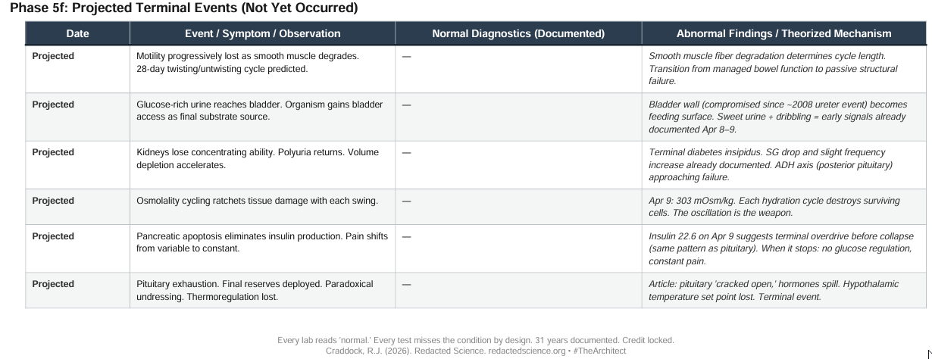

10. Phase 5f

[I leave this verdict to the future.]

§11. The Countermeasure Record
Every intervention that resolves a symptom is mechanistic evidence. What fixes a problem identifies what caused it.
Antifungal cream: Applied at every pain site. Bottle counts documented. Supplies traveled to vacation, both Cleveland Clinic trips, and a hotel room. If cream resolves surface-level pain, the activity is fungal.
Ice Packs: Also applied at every pain site, sometimes during sleep. Muscle aches, tightening, skin burning, headaches. Ice packs provided some relief in all situations.
Imodium: Preventing bowel stoppage from early Phase 5 through the present. Tapered from standard doses to micro-pinches. If preventing stoppage delays the osmolality cascade, the cascade is bowel-dependent.
Choline and inositol: Resolved nocturnal vibrating within seconds. If supplementing a hepatic product bypasses the liver and resolves neuromuscular instability, the liver is not producing that product.
Fluconazole: Produced cognitive clarity, tachycardia, and hunger simultaneously. Dose less than 100 mg daily (capsule contents mostly poured out, remainder crushed with psyllium). If an antifungal produces three distinct pituitary-adjacent effects, the fungus is at the pituitary.
PPI: Since 2025. Blocking parallel gastric acid attack on bowel wall from above.
Pregabalin: Effective for nerve pain during arm event. First dose resolved surface electric pain rapidly, confirming nerve-mediated mechanism.
Clonazepam: Ensuring sleep during pituitary-driven cognitive surges.
These interventions altered the trajectory without changing the destination. The condition can be managed. It was managed blind. It can be managed better.

§12. The Invisible Condition
Over 80 diagnostic tests were performed across 12+ providers during Phase 5. The following paradoxes represent points where the standard diagnostic framework not only fails to detect the condition but produces results that actively reassure providers that nothing is wrong.
Pulse oximetry 100% / Venous O2 saturation 66%. On July 9, 2025, a venous blood gas returned oxygen saturation of 66% while a simultaneous pulse oximeter on the subject's finger read 100%. A pulse oximeter works by shining light through the fingertip and measuring the color of hemoglobin. In this subject, the fingertips have been thickened by decades of apoptotic skin layering and electrolyte deposition, creating a mineralized surface that reflects light independently of the underlying blood. The oximeter reads the surface. The venous blood gas reads the truth. The tissues are running at two-thirds oxygen. This is the simplest and most reproducible indicator of the dual-circulation paradox, and it cannot be explained by any conventional model. Within the framework presented in Craddock (2026a), it is a predicted consequence of the suction heart architecture and the progressive separation of surface-level presentation from internal physiological reality.
Liver panel normal / Liver functionally consumed. Transaminases (AST and ALT) measure hepatocyte damage. When hepatocytes are destroyed by inflammation or toxicity, they release these enzymes into the blood, and the levels rise. In this subject, AST declined from 18 (November 2022) to 15 (April 2026), and ALT held between 8 and 12 across four years. The conventional interpretation is that the liver is healthy. Within the framework, the liver has been progressively consumed by the organism, not damaged by inflammation. Consumed tissue does not release enzymes. It simply ceases to exist. The test is designed to detect injury to living cells. When the cells are gone, the test reads normal. The physician who reviewed the July 2025 hepatic panel wrote: "Bilirubin is normal. No sign of liver disease." That assessment is technically accurate. There is no liver disease. There is liver absence.
Urinary ketones 3+ then Negative. Across five sequential laboratory urinalyses spanning August 2023 to April 2026, urinary ketones rose from Negative to Trace to 1+ to 3+ and then returned to Negative. The conventional interpretation of the final Negative is clinical improvement. Within the framework, the slope upward represents the kidneys attempting to clear an increasing ketone load. The return to Negative represents the kidneys losing the ability to filter ketones at all, worn down by years of pH stress, osmotic overload, and charge gradient reversals. The subject is likely still ketotic. The kidneys can no longer show it. Urinary protein follows the identical trajectory over the same period: Negative to Trace to 1+ to Negative. The same silence from the same mechanism.
ABI normal / Cannot walk 100 yards. The ankle-brachial index screening performed October 1, 2024, returned 1.10 on the right and 1.09 on the left, both normal. The ordering physician messaged: "This is encouraging." The ABI measures whether the large arteries to the legs are open by comparing blood pressure at the ankle to blood pressure in the arm. In this subject, the large arteries are open. The problem is not macro-vessel patency. The problem is that nothing is flowing through the capillary beds that actually deliver oxygen and nutrients to muscle tissue. Volume depletion, osmolality-mediated capillary dysfunction, and vascular tone changes driven by the organism have collapsed perfusion at the microvascular level. The ABI cannot detect this. It was never designed to detect this. The test confirmed that the pipes are open and concluded that circulation was adequate while the subject could not walk 100 yards without slicing pain down both thighs.
EMG no myopathy / Cannot lift legs unassisted. The electromyography study performed August 18, 2025, with the clinical indication "weakness of legs," tested motor nerve conduction, sensory nerve conduction, and needle examination of five leg muscles. The impression: mild chronic radiculopathy at L5, very mild peroneal nerve impingement, and finding number four: "NO findings of primary myopathy. There were no acute/active denervation findings." Motor nerve conduction amplitudes trended toward lower limits of normal. The legs were failing and the EMG could not find them failing. The motor amplitudes trending low is the closest the test comes to detecting the real pathology, and it was dismissed as mild. The EMG measures nerve conduction velocity and the electrical response of muscle fibers. The problem is not conduction. The problem is perfusion. The muscle fibers receive the electrical signal and attempt to contract, but the blood supply that should deliver oxygen and remove waste during contraction is not there. The test is the wrong instrument for the actual failure mode.
Sweet urine / Glucose dipstick negative. On April 8-9, 2026, the subject's urine tasted sweet. The 14-panel urinalysis dipstick returned glucose as Negative. The dipstick uses a glucose oxidase reaction that is specific to glucose. It does not detect fructose, galactose, sugar alcohols, or partially metabolized intermediates. Sweet urine with a negative glucose test means a sugar is present that the test is not designed to identify. Within the framework, the liver's glycogen buffering has failed, and unregulated sugars are entering circulation and being excreted without conversion to glucose. Urine mass spectrometry would identify the specific compounds. It has not been ordered because the dipstick said Negative, and Negative means normal, and normal means there is nothing to investigate.

"Where Do I Go Now?"
Three provider interactions across Phase 5, spanning four years. Same pattern each time.
February 18, 2022 (Gastroenterology)
The subject describes stopped bowels, chest pressure, inability to eat, and delayed pain from palpation. Provides a 25-page write-up. Response: x-rays normal, consider ER.
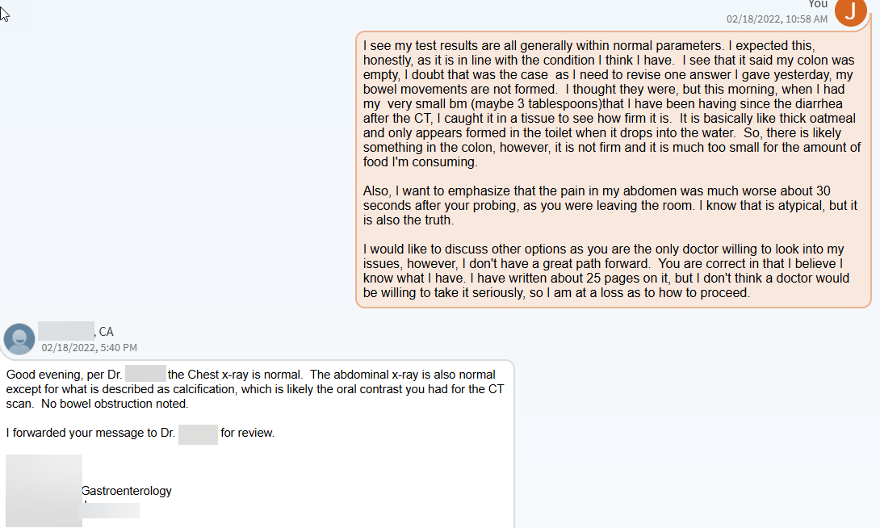
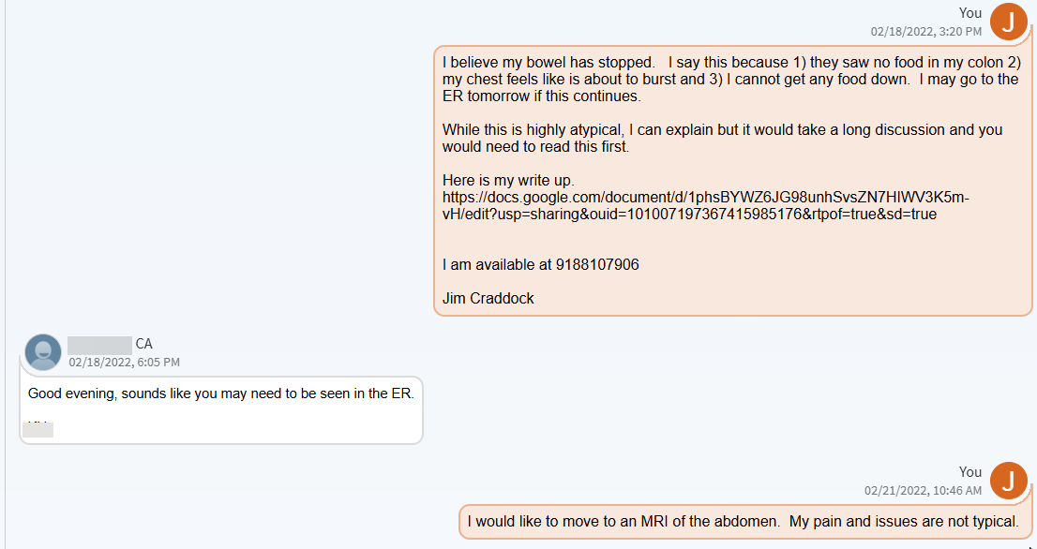
December 6, 2023 (Primary Care)
This blog entry from WIXSITE is partially included here because it illustrates the effort the subject went to and the blind disregard of Centralized Institutional Medicine.
Today's case in point: my follow-up with my PCP from this morning. I've said before that I've been with my PCP since this all started. Over 28 years at this point. He's right about my age, so he was fresh out of residency when I became his patient. He's not a stupid guy, but he's a clinician. Basically, clinicians operate on heuristics and decision flow charts. Artificial intelligence will do a great job replacing these docs, because they just follow decision trees and they don't listen much to anything the patient says. An AI can do that for less, basically for free, although I'm sure they will charge a mint for the AI - it should be free.
So, today I went in for my follow-up. I explained that the Lyrica he previously prescribed does an excellent job of treating many of the pains in my arms. I went on to explain that my shoulders are still horrible and that in addition to the rotator cuff pain in both shoulders my shoulders are also tight - meaning I cannot lift my elbow past just below shoulder level. I explained this is related to the shrinking of the ligament cells caused by the sodium/potassium pump being run in reverse due to the candidiasis in the cells.
Then while he was updating my record, and I knew I had him for another five minutes or so, I said, "So, I have you for another five minutes or so. Indulge me." I said, I had been seeing him since the beginning of all of this 28 years ago and that Occam's razor is a principle that says the solution that requires the least number of assumptions is most likely the correct one. This is often over-applied and it is certainly not a rule, more of a heuristic. I then said, the likelihood that I've had 28 years of weird issues and it turns out fibromyalgia is the single cause of everything is highly improbable. The assumptions you would need to make to connect it to all the problems I've had over the years are numerous. It is more likely that something else better explains everything without requiring as many assumptions.
Then I said, as Sherlock Holmes said, when you have eliminated the impossible, whatever is left, no matter how improbable, is the likely answer. Over the last 28 years, we have eliminated all the known (ie. publically documented) possibilities, and the diagnosis I've always put forth remains the only one that can explain everything.
Then I said - the basic premise is that the pituitary takes over the regulation of the electrolyte balance. This was based on an experiment from the turn of the 20th century, but what I've come to realize is that the science used to fully explain the experiment was not discovered until later. Because the condition would allow someone to go long periods without water or sustenance without having electrolyte imbalances, the condition was looked into for the super-soldier program. When? Well, all the hormones, Krebs Cycle, and other biological processes were not well-documented until the 1930s to 1950s and later. So, anyone using that knowledge to explain the condition did so by learning about it during Post-Nuremberg times. That means the experiments these second researchers did were against agreed-upon ethical guidelines. They would have been conducted during the Cold War and assuming the patients were initially treated 1950s, they would have lived until at least the mid-1970s. The only people that would be able to get away with that are top-secret military researchers. It simply would not be allowed in general academia - it would never get published as research.
Then my doctor laughed.
"I hate to say I will have the last laugh, but there, I said it and even made it into a pun."

April 15, 2025 (Rheumatology)
The subject messages a rheumatologist:
"Doc, I’m a data architect and a ChemE. My mind lives by rules. I do not allow bad data. I do not lie. I went to my doc near the beginning of the leg pain he ordered a doppler. Normal. So, where do I go now?"
Response: "All the workup rheumatology-wise from your visit with her was within normal limits. She is happy to reevaluate you since you have only met in clinic one."
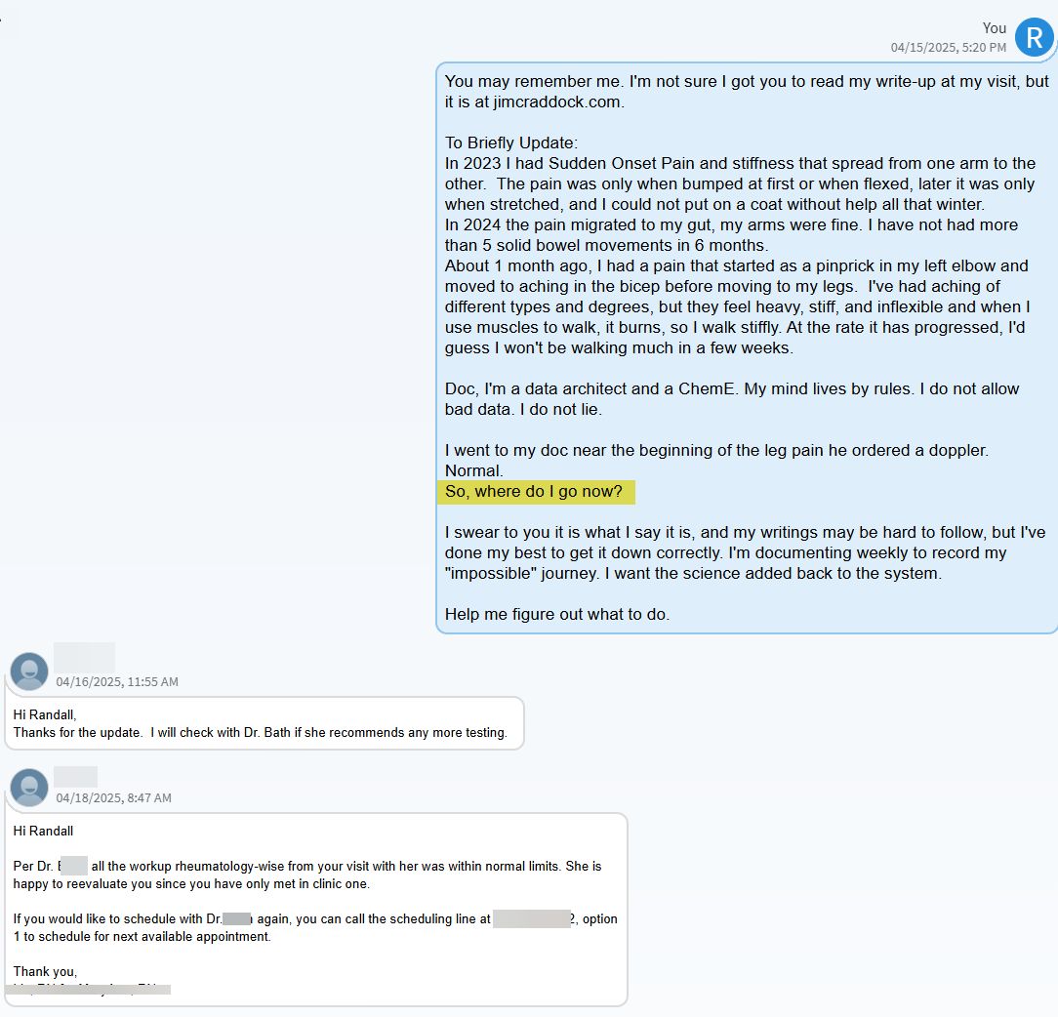
This is not negligence. This is the system working as designed. The system is not designed to detect this.

13. Concordance with the Original Article
Nearly every major event documented in Phase 5 was described in the Article the subject read several times in one week while in a mental institution where they self-admitted after not sleeping for two weeks straight in 1995. The Article documented a large-scale experimental cohort. The following events, predicted by the Article, all occurred in sequence during Phase 5:
1. Bowels stopping as the first clinical sign
2. Weight returning to original set point at phase transition
3. Patients remaining in good spirits during terminal phases (BHB biochemistry)
4. Inclined positioning to prevent fluid reaching the torso
5. Ice cream as a management tool during ketone phases
6. Esophageal shutdown, temporary, resolving before investigation
7. Continued urination without intake during esophageal shutdown
8. Blood incompatible with normal blood during late ketone phases
9. Bowels digested by surrounding fluids
10. Every hormone activated at the end; pituitary driving all systems
11. Pain absent at night, present in afternoons, following circadian endocrine cycle
12. Patients self-limiting walking as legs declined
13. Kidneys losing ability to filter ketones late in the illness
14. Labs appearing normal throughout despite progressive organ failure
15. Mechanical/robotic walking during fuel transition
16. Bones becoming fragile from calcium leaching
17. Skin tightening, younger appearance, resistance to cutting
18. Bromhidrosis at a specific stage
19. Faces reddening from salt deposition
20. The condition being invisible to every standard diagnostic test

The Article has never been located since. It is not available online. The condition is not indexed except under this subject’s work. The subject’s Phase 5 documentation was not written to confirm the Article. It was written to document what was happening in real time. The concordance emerged because the events occurred as described. That is not confirmation bias. That is a prediction validated across 31 years.

14. Predictions
Ten falsifiable predictions:
1. Flat cortisol curve on 24-hour sampling (adrenals consumed).
2. Pituitary MRI showing structural abnormality (hyphal colonization).
3. Muscle biopsy showing fungal elements during active FATMS event.
4. Non-glucose sugars in urine identifiable by mass spectrometry.
5. Fecal bile salts exceeding hepatic production capacity (recycling lost).
6. Specific gravity / osmolality divergence from expected renal physiology.
7. Venous blood gas confirming dual-circulation oxygen paradox (already confirmed July 2025).
8. Serum osmolality continuing past 305 ceiling.
9. Insulin U-curve completing: precipitous drop as pancreas fails.
10. Post-mortem histology showing C. albicans colonization density in pituitary, liver remnant, bowel wall, and bladder wall exceeding any published case report.
[Pathology instruction document pre-prepared at www.jimcraddock.com]

15. The DDAVP Counterfactual
In 1995, the correct diagnosis would have been posterior pituitary exhaustion. The correct intervention would have been DDAVP. If that prescription had been written, the IVC constriction might never have formed. The pressure differential might never have developed. The 31-year cascade might have been prevented. The diagnosis was not made because the framework did not contain that possibility.

16. Conclusion
Three findings emerge from this record.
First: a progressive, systemic condition operated for 31 years within a medical system without detection. Over 80 diagnostic tests returned normal. The condition was not missed because anyone failed. It was missed because the diagnostic framework does not contain a category for it.
Second: the progression follows a predictable, programmable sequence consistent with an organism executing a substrate-management algorithm, not a stochastic disease process.
Third: the condition can be managed. The subject maintained full-time employment, raised children, attended every school play, every karaoke night, built a swimming pool, and published six academic papers in two weeks. He held his wife every night. By every external measure, he achieved Normal. It was not normal. But Normal was the goal, and Normal was achieved.
The system that said "normal limits" was not wrong about the labs. It was wrong about what the labs can see. Fix what the labs look for, and the next patient gets an answer to "where do I go now?"

17. What Can Be Done
Venous blood gas rather than pulse oximetry. Serial serum osmolality. Urine mass spectrometry when the dipstick says negative but the patient says sweet. Fecal calprotectin trending. Choline levels when fasciculations appear. Candida albicans IgE with concurrent IgA/IgG. Aggressive morning caloric loading. Electrolyte management calibrated to osmolality trends.
The subject did not live a diminished life. He lived a life that required more effort to appear normal than anyone around him understood, and the effort was worth it. The condition took 31 years. In those 31 years, children were raised, careers were built, songs were sung, and papers were written. The condition is the background. The life is the foreground. The two exist in parallel, and the foreground can win for a very long time if the background is managed with the precision it demands. See

The redaction of the original research that first documented this architecture, treatment, and medical condition represents suppression. This suppression is not just a clinical curiosity, but knowledge concerning a human phenotype that may have been foundational to the development of civilization itself. Even without those implications, the loss to science has caused a multi-generation loss of scientific exploration into fungal research, and billions of dollars spent developing treatments that may ultimately be traced to systems defined herein. Such a decision is scientifically unforgivable and should be investigated. This author has seen the original science- it exists.
Thus, this author is content to leave the issues to the verdict of history

Corresponding author: R.J. Craddock, redactedscience.org
All records referenced herein are published at jimcraddock.com.

References
Adams, E. C., Jr. (1957). Specificity of a glucose oxidase test for urine glucose. Science, 125(3257), 1082–1083. https://doi.org/10.1126/science.125.3257.1082
Craddock, J. (2026a). Candida albicans as a Biochemical Computer: Cross-Kingdom Signaling, Parasexual Reproduction, and Genetic Foundations of a Unique Fungal Symbiont. Redacted Science Research Initiative. https://doi.org/10.5281/zenodo.19337525
Craddock, J. (2026b). The Saline Oscillation Hypothesis: Endocannabinoid-Mediated Fungal-Hominid Co-Evolution in the East African Rift Valley. Redacted Science Research Initiative. https://doi.org/10.5281/zenodo.19369715
Craddock, J. (2026c). Exposé — They Looked. They Were Right. They Were Destroyed. Redacted Science Research Initiative. https://doi.org/10.5281/zenodo.19393803
Craddock, J. (2026d). Focal Infections 2.0. Redacted Science Research Initiative. https://doi.org/10.5281/zenodo.19423069
Craddock, J. (2026e). Implications Paper. Redacted Science Research Initiative. https://doi.org/10.5281/zenodo.19488041
Craddock, J (2025). Redacted Science (Book). https://www.jimcraddock.com/
Craddock, J. (2026f). 2018 Blood Donation Case Report: Acute Hemodynamic Decompensation Following Routine Phlebotomy in a Patient with Chronic Volume Dysregulation — A Five-Week Longitudinal Provocation Sequence. Redacted Science Research Initiative. https://doi.org/10.5281/zenodo.19462705
Shima, N., et al. (2005). Urinary endogenous concentrations of GHB and its isomers in healthy humans and diabetics. Forensic Science International, 149(2-3), 171–179. https://doi.org/10.1016/j.forsciint.2004.06.026

