Deeper Dive: Network Intelligence, Fungal Adaptation, and the Architecture Behind Redacted Science
You’ve heard of brain fog. Chronic fatigue. Vague gut issues. Thermoregulation problems. Loss of drive, identity, and clarity — all dismissed as “psychosomatic,” “normal aging,” or “unexplained.” But what if that’s a cover story? What if these symptoms are the output of a deeper biological system — one being slowly rewritten by a distributed fungal presence?
This piece isn’t theory. It’s pattern recognition backed by peer-reviewed evidence, nanotechnical validation, and personal experience across 30 years of unexplained collapse and cognitive clarity. If you've ever suspected something was rewriting your systems from the inside — you weren’t wrong.
The central argument of Redacted Science is that what the medical world calls dysfunction may in fact be an adaptive, distributed fungal system—one that reprograms the host through subtle rewiring of reward circuits, blood flow, thermal regulation, and memory. Today, this thesis finds unexpected support across multiple fields: mycology, nanotech, wearable computing, and military systems modeling.
This is a deeper dive into the evidence that science has already uncovered—but failed to connect.

📉 From Decline to Pattern Recognition
In 2008, Jim Craddock—a lifelong systems builder and observer—experienced a sudden, unexplained drop in performance. His Tulsa Run time degraded by over 90 seconds per mile with no change in training. Years later, he would lose his ability to sweat. In 2021, it stopped entirely. Only after a massive physiological transition in 2022 did sweating return—erratic, misrouted, and unpredictable.
The system hadn’t failed.
It had rewired itself.
Preserving fluid. Saving electrolytes. Prioritizing brain perfusion.
Denying all outputs not deemed critical.
In hindsight, this was not collapse. It was an invader’s long game.

🦠 A Fungal Architecture Already Known
The 2024 review Humans vs. Fungi by Thambugala et al. catalogued 281 human fungal pathogens—divided into superficial, subcutaneous, and systemic classes—and emphasized that these pathogens thrive through interaction between host vulnerability, environmental conditions, and pathogen adaptation. A simple Venn diagram in the paper shows what medical systems ignore: disease occurs at convergence.^{[2]}

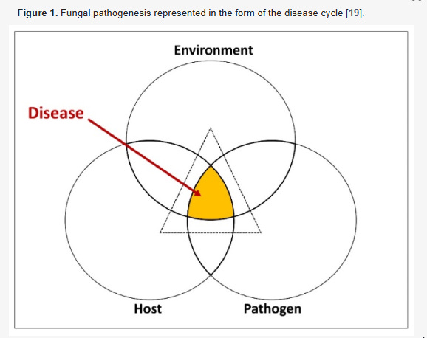

But the fungi don’t just invade—they coordinate.
Aspergillus, Candida, and Cryptococcus are not isolated threats; they are networked agents, capable of surviving immunologically, neurologically, and chemically.^{[2]} Candida, in particular, lives endogenously in most humans. When conditions shift—pressure changes, endocrine weakening, nutrient flux—it doesn’t die. It adapts.
The result is not sepsis.
It’s subclinical rerouting, at the scale of the body.

🧵 Fiber Computers and Emergent Intelligence
In February 2025, MIT researchers unveiled a distributed "fiber computer" system—threads that could run apps, communicate with each other, and sense physiological changes in the wearer. One line in their paper stands out:
“Surprisingly, once the researchers allowed the individual fiber computers to communicate among themselves, their collective accuracy increased to nearly 95 percent.”^{[4]}
That’s Redacted Science’s central warning:
Once the fungus can communicate across compartments, it behaves as a system.
Just as those fibers increased performance through coordination, the fungal presence—when it bridges gut, skin, vasculature, and neuroendocrine hubs—achieves adaptive intelligence. Not conscious thought, but functional intelligence: survival optimization. Chemical computing. State-switching. Networked intent.
The human host is not overpowered.
He is reprogrammed.

⚙️ Nanotech Meets the Problem—But Doesn't Name It
A 2021 paper in Nano Convergence described a diatomaceous earth–zinc oxide nanocomposite (DE-ZnO) engineered to attack fungal and bacterial pathogens. It worked not through toxicity alone, but through:
- High surface-area pathogen binding
- ROS and ion-based signaling disruption
- Synergy with traditional antifungals
This is exactly what Redacted Science theorized without the microscope:
To defeat fungal intelligence, you must interfere with its signaling, not just poison its shell.^{[1]}

🎖️ Performance Degradation is Layered — and Predictable
In 2001, the U.S. Army Research Lab’s IMPRINT model predicted layered degradation for pilots in high-stress scenarios.^{[3]} Their conclusion?
Failure is not linear—it’s layered.
Cognitive load, oxygen shifts, visual occlusion, and equipment burden compound until systems break unpredictably.
Craddock’s model is the biological twin:
- Pressure drop → vascular reroute
- Vascular reroute → reward collapse
- Reward collapse → thermoregulation shutdown
- Thermoregulation shutdown → fluid conservation override
- Override → new identity, not just new symptoms
This isn’t multitasking failure.
It’s intent erosion.^{{3}}

🔚 If the System Knew, Why Didn’t the Doctors?
Medical diagrams—like those in Thambugala’s paper—clearly show how fungal infections move from skin to organs, from surface to blood.^{[2]}

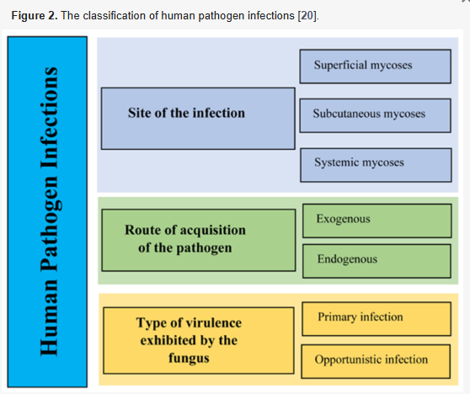

Yet no current protocol connects vascular pain after meals, loss of sweating, reversible alopecia, or pituitary decay to Candida albicans—a species affecting nearly one-third of the human population.^{[2]}
Why?
Because the system forgot to ask whether these processes were intelligent.
Because a distributed fungal network doesn’t look like a disease.
It looks like entropy.
It looks like aging.
It looks… like nothing.
Until you connect the steps.
Until you feel it reroute you.
Until it speaks through pressure, and silence, and sweat withheld.
And by then, you're already being redefined.
Redacted Science – Free
References
[1] Liu, H., Qiao, Z., Jang, Y.O., Kim, M.G., Zou, Q., Lee, H.J., Koo, B., Kim, S.-H., Yun, K., Kim, H.-S., & Shin, Y. (2021). Diatomaceous earth/zinc oxide micro-composite assisted antibiotics in fungal therapy. Nano Convergence, 8, 32. https://doi.org/10.1186/s40580-021-00283-6
[2] Thambugala, K.M., Daranagama, D.A., Tennakoon, D.S., Jayatunga, D.P.W., Hongsanan, S., & Xie, N. (2024). Humans vs. Fungi: An Overview of Fungal Pathogens against Humans. Pathogens, 13(5), 426. https://doi.org/10.3390/pathogens13050426
[3] Salvi, L. (2001). Development of Improved Performance Research Integration Tool (IMPRINT) Performance Degradation Factors for the Air Warrior Program (ARL-TR-2311). Army Research Laboratory.
[4] Zewe, A. (2025, February 26). Fiber computer allows apparel to run apps and “understand” the wearer. MIT News. https://news.mit.edu/2025/fiber-computer-allows-apparel-to-run-apps-and-understand-wearer-0226

Redacted Science — Free | https://redactedscience.org

